Aim: Apply non-linear filters on images and investigate its application in noise-removal.

Theory:-
- Non-linear filters are image processing techniques used for noise removal by considering the
local neighborhood of each pixel. Unlike linear filters, non-linear filters modify pixel values
based on their relationship with neighboring pixels, allowing them to effectively suppress
different types of noise.

Programm:-

import cv2
from google.colab.patches import cv2_imshow
import numpy as np
import os
image_files = [

"/content/smoothening data.png",
"/content/smoothening data2.png",
"/content/smoothening data3.png",
"/content/smoothening data4.png",
"/content/smoothening data5.png",
]
output_dir = "/content/filtered_images"
os.makedirs(output_dir, exist_ok=True)
filtered_images = []
for idx, file in enumerate(image_files, start=1):
img = cv2.imread(file)

if img is None:

print(f"Could not read {file}")

continue
filtered_img = cv2.GaussianBlur(img, (7, 7), 0)
filtered_images.append(filtered_img)
save_path = os.path.join(output_dir, f"filtered_image_{idx}.png")
cv2.imwrite(save_path, filtered_img)

print(f"Saved: {save_path}")
Saved: /content/filtered_images/filtered_image_5.png
heights = [img.shape[0] for img in filtered_images]
widths = [img.shape[1] for img in filtered_images]
min_height = min(heights)
min_width = min(widths)
resized_images = [cv2.resize(img, (min_width, int(img.shape[0] * min_width / img.shape[1])))

for img in filtered_images]
grid = np.vstack(resized_images)
cv2_imshow(grid)

Original Image:

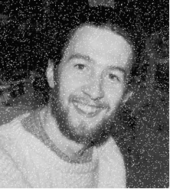
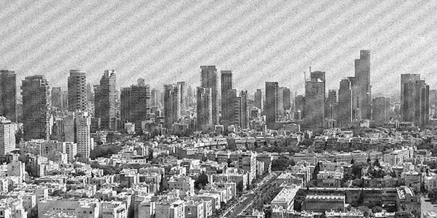

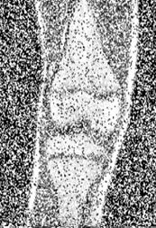
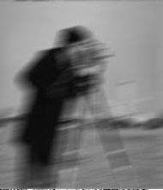
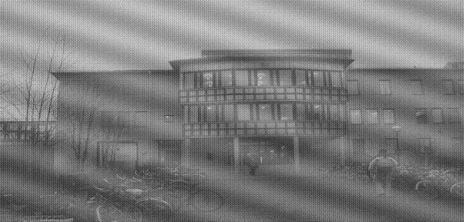

Output image:
